Description

In this application, the card game war was implemented.

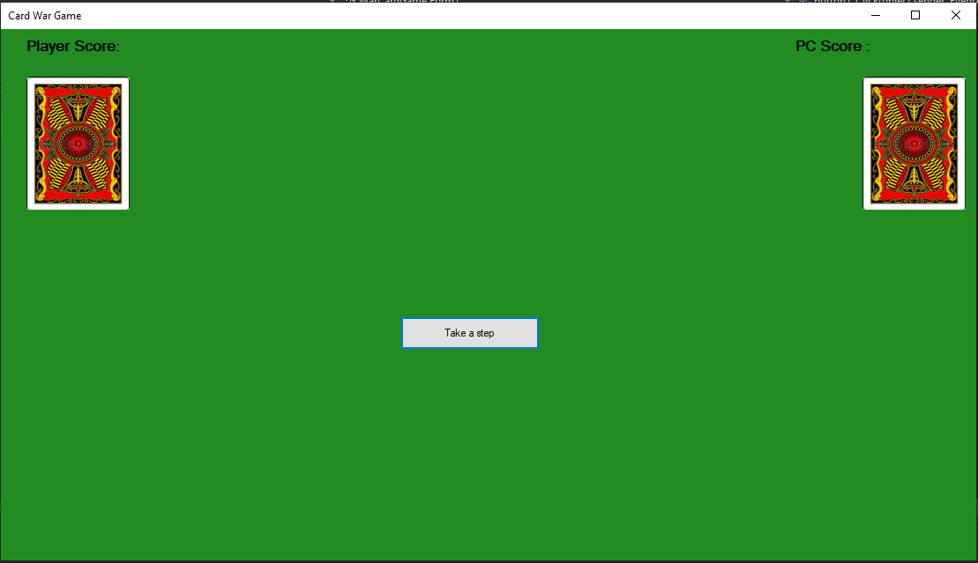

Further, when you press the move button, cards appear and are compared by value, ignoring the suit

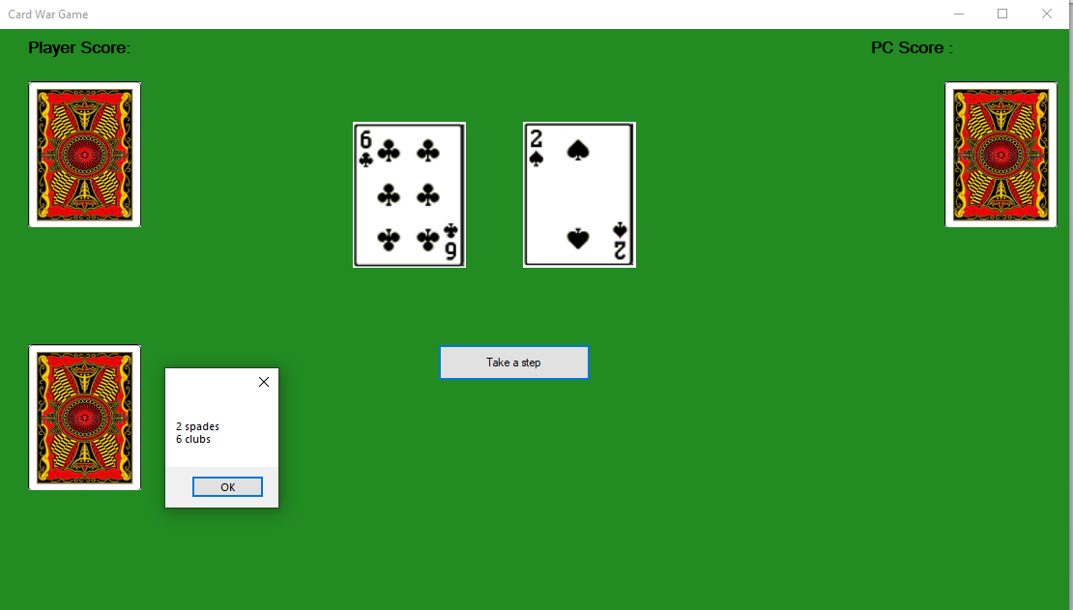

From the comparison, it can be seen that the value of the player's card is greater than the computer's card, therefore, at the bottom left (where the player's side is), a pile of upside-down cards is displayed, indicating that the player takes both cards. If you click on the pile that appears, the names of the cards won are displayed.

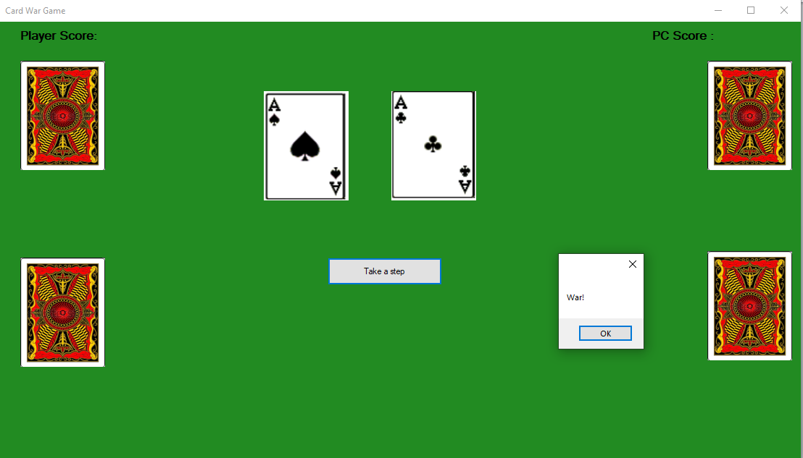

Further, if you make moves, sooner or later two cards of the same value will appear, then a window will appear with this display of the beginning of the dispute.

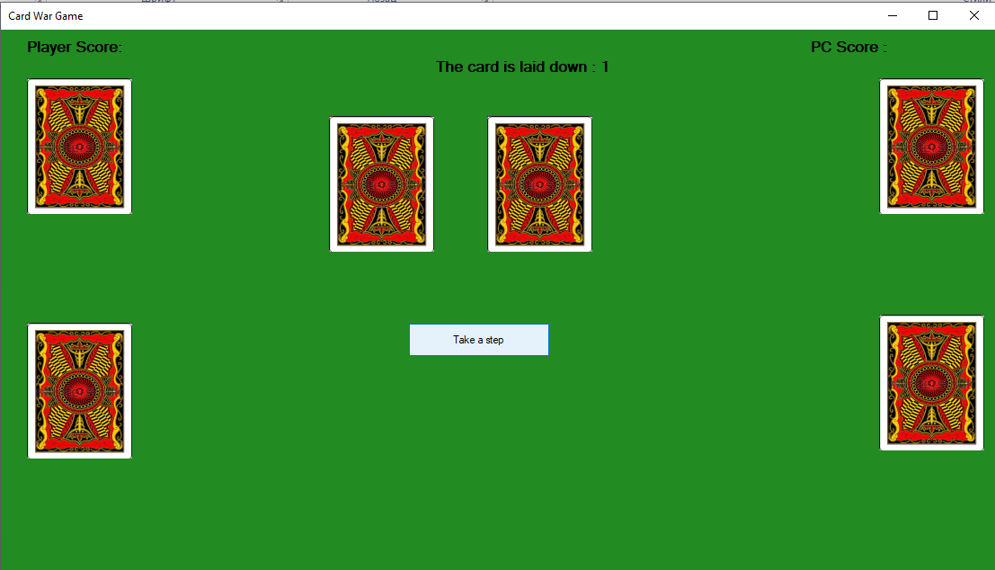

then clicking on the button to make a move, we put the cards face down three times.

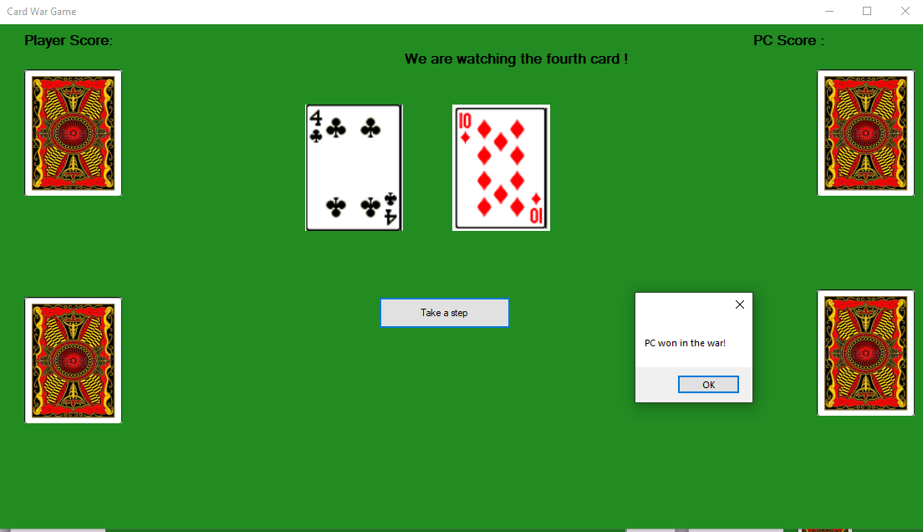

and on the fourth turn the cards are shown face up and are compared again, and whose card has a higher value, he takes all the cards for himself.

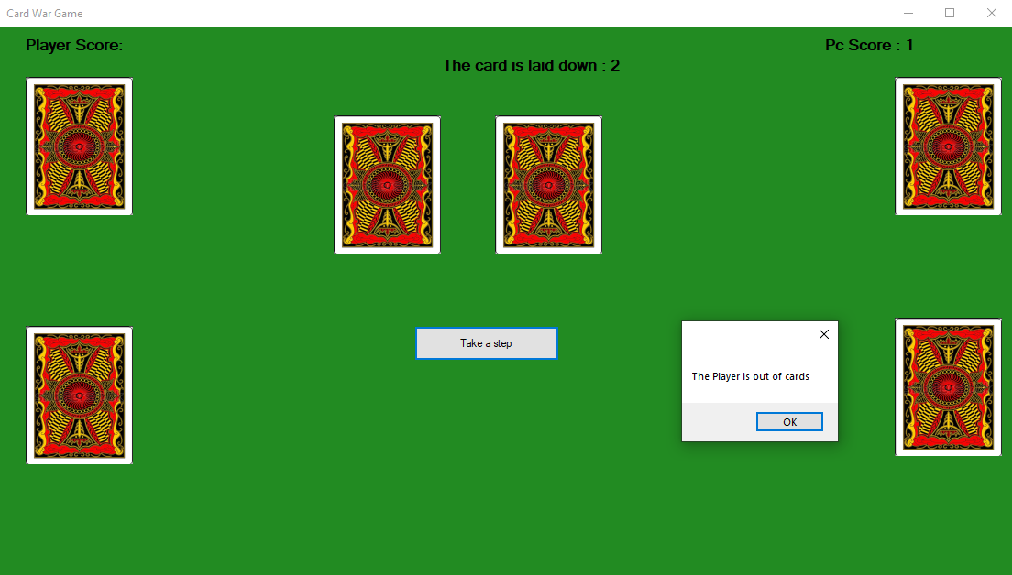

If one of the players runs out of a deck, then the player takes cards from those that he won before and fills his working pile of cards with them, the game continues. However, in this case, the opponent gains one point.